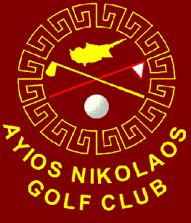
AYIOS NIKOLAOS GOLF CLUB
2020 UMI SENIORS OPEN
18 FEB 2020

Format: 18 hole Nett Strokeplay competition with Gross Prizes.

Eligablilty: Gentlemen golfers aged 50 and above holding a valid WHS or CONGU handicap. Non CGF affiliated golfers will be required to provide H/C certificates.

Rules: Played in accordance with the Rules of Golf and ANGC Local Rules. Ties to be settled on count back. Playing handicaps will be capped at 28 for the competition.

Entrance fee: €23 includes a polo shirt, tea and toast and a post event meal.
Any Competitors included in the draw and subsequently cancelling are liable for the entry fee. Payment to be made in CASH on the day.

Closing Date: 17:00hrs Monday 3rd February

The draw will take place no later than Sunday 16th February 2020 and will be posted on the Club website: www.aynik.club

--------------------------------------------------------------------------------------------
ENTRY DETAILS
(For completion by non ANGC pass holders)

NAME: WHS /CONGU Handicap:

EMAIL: MOBILE:

PASSPORT NO: DATE OF BIRTH:

CAR REG & MODEL: NATIONALITY:

COMPLETED ENTRY FORMS TO BE RETURNED TO
email: compsec@aynik.club

